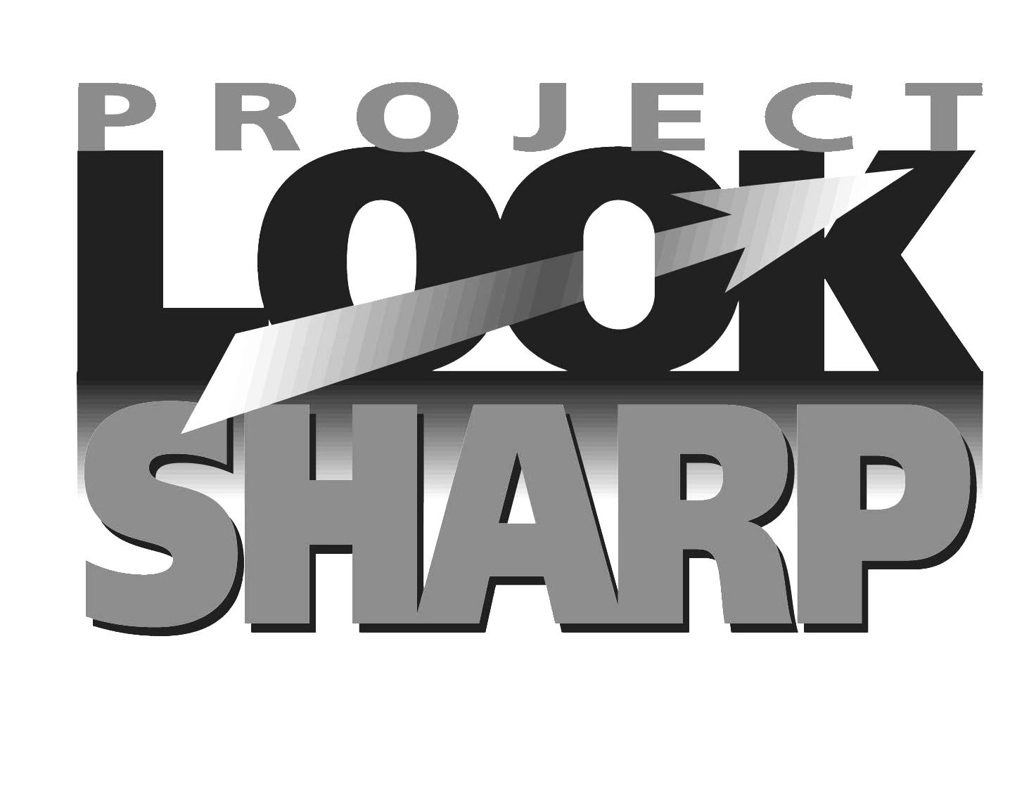

KEY QUESTIONS TO ASK WHEN PRODUCING MEDIA MESSAGES

www.projectlooksharp.org
www.namle.net

AUDIENCE & AUTHORSHIP | Authorship | Who am I representing in making this message?
AUDIENCE & AUTHORSHIP | Purpose | Why am I making this?  Who is my target audience, and what do I need to do to reach them?
AUDIENCE & AUTHORSHIP | Economics | Who is sponsoring or paying for this? In what ways do funding sources affect my message?
AUDIENCE & AUTHORSHIP | Impact | Who might benefit from this message (and how)?  Who might be harmed by it (and how)?  What is my responsibility to my audience?
AUDIENCE & AUTHORSHIP | Response | What kind of response do I want from my audience?
MESSAGES &  MEANINGS | Content | What messages and impressions do I want to convey?  What ideas, values, information, and/or points of view do I want to make explicit? Implied?  What will I leave out of this message and why (and how will that affect the message)?
MESSAGES &  MEANINGS | Techniques | What production techniques will work best (for this type of message, to reach this audience)?
MESSAGES &  MEANINGS | Inter-pretations | How might different people understand this message differently?  What do I learn about myself from my role in creating this message?
REPRESENTATIONS & REALITY | Context | Where or how will I share this with my audience?  How long will this message stay relevant?
REPRESENTATIONS & REALITY | Credibility | What sources am I using for information, ideas, and assertions, and why have I chosen those sources over other possible sources?  Is the information in this message accurate and how will the audience be able to know that?  Is my presentation of information and ideas fair?

