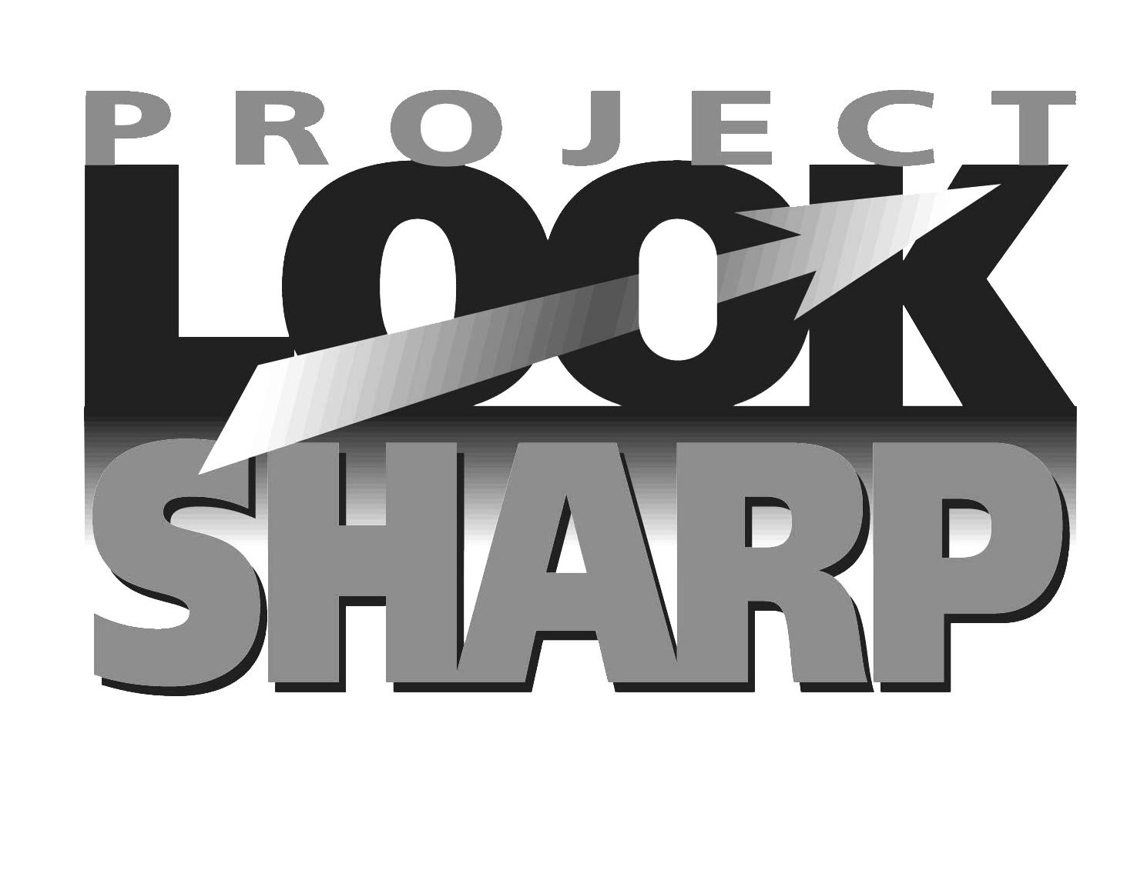


KEY QUESTIONS TO ASK WHEN ANALYZING

MEDIA MESSAGES

www.projectlooksharp.org
www.namle.net
AUDIENCE & AUTHORSHIP | Authorship | Who made this message?
AUDIENCE & AUTHORSHIP | Purpose | Why was this made?  Who is the target audience (and how do you know)?
AUDIENCE & AUTHORSHIP | Economics | Who paid for this?
AUDIENCE & AUTHORSHIP | Impact | Who might benefit from this message?  Who might be harmed by it?  Why might this message matter to me?
AUDIENCE & AUTHORSHIP | Response | What kinds of actions might I take in response to this message?
MESSAGES &  MEANINGS | Content | What is this about (and what makes you think that)?  What ideas, values, information, and/or points of view are overt? Implied?  What is left out of this message that might be important to know?
MESSAGES &  MEANINGS | Techniques | What techniques are used?  Why were those techniques used?  How do they communicate the message?
MESSAGES &  MEANINGS | Interpretations | How might different people understand this message differently?  What is my interpretation of this and what do I learn about myself from my reaction or interpretation?
REPRESENTATIONS & REALITY | Context | When was this made?  Where or how was it shared with the public?
REPRESENTATIONS & REALITY | Credibility | Is this fact, opinion, or something else?  How credible is this (and what makes you think that)?  What are the sources of the information, ideas, or assertions?

